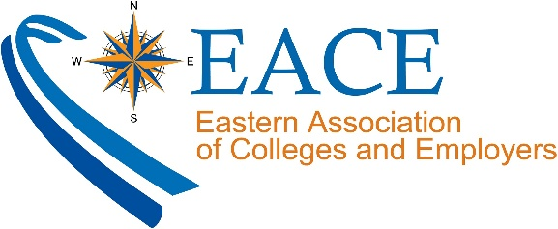
Dear _____,
I want to personally invite you to join the Eastern Association of Colleges & Employers (EACE). As an HR/recruiting professional trying to expand your early-career recruiting efforts in the Northeast, there are numerous benefits to joining! Plus, if you join in February, you’ll receive $125 off EACE 2020 Annual Conference registration! Here are the top 4 reason for employers like you to join:
- Build your brand and recruitment pipeline by connecting with 1,900+ career services professionals representing more than 250 colleges throughout the Northeast!
- Receive discounted pricing to the Annual Conference. EACE20 will be held August 5-7 in Baltimore, MD and will offer more than 35 workshops, many of which qualify for HRCI and/or SHRM credit.
- Participate in free signature programs including Road Trips to the Real World and Professional Exchange to build new relationships with college career centers and our students. Don't miss your chance to register for 2020 Professional Exchange! The deadline is April 3, 2020.
- Take advantage of free webinars year-round, including access to the robust archive of recordings.
You can help me out too! The first five (5) EACE Members who refer a new employer receives $100 off EACE20 registration. Don’t forget to include my name and organization in the referral field of the membership application form!

HURRY AND JOIN TODAY AT WWW.EACE.ORG!

Fine print: Employer must not have held previous membership with EACE. New memberships must be paid during the month of February to be eligible to receive the EACE20 promo code. One promo code per individual or group membership. Eligible employers will receive promo code via email within one week from date payment is made.

