2023 Road Trips to the Real World & Professional Exchange
Employer Host Registration Form

Below is a copy of the online registration form.
For: College/university students & alumni  When: January 2023  Employer Host Deadline: October 7, 2022  Click here for more info on the virtual Road Trips to the Real World (RTRW) program.  In-person options may become available. If interested, indicate on the form below. | 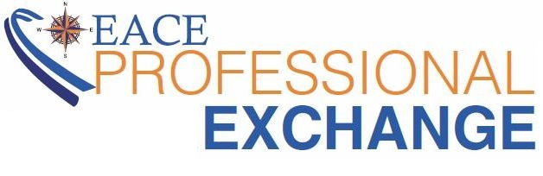  For: College/university career services professionals  When: Summer 2023  Employer Host Deadline: April 4, 2023  Click here for more info on the virtual Professional Exchange (PE) program.  In-person options may become available. If interested, indicate on the form below.
Employer hosts must use their own virtual meeting platform in order to conduct the site visit. If you are registering for both programs, you may submit a separate registration form for each.
Which program are you registering for?
- Road Trips to the Real World
- Professional Exchange

Virtual Site Visit Information:
Company Name:
Physical Company Address:

RTRW student site visits take place on dates Wednesday, January 4 through Friday, January 20, 2023. Professional Exchange site visits take place on dates Monday, June 5 through Friday, August 11, 2023.

Preferred Date:

Alternate Date:

Start Time in ET:

End Time in ET:

What platform are you using for this virtual site visit?

Will you be able to provide closed captioning?

Minimum Number of Participants Required (if applicable):

Maximum Number of Participants (if applicable):

Brief Company Overview (To be used in promotional material & website.)

Site Visit Agenda/ Overview of What to Expect (To be used in promotional material & website.)

Company Industry:

Which of the following will you be discussing?
- Internships
- Entry-Level Jobs
- Both internships and entry-level jobs

What college majors are you currently recruiting?

What are the main types of positions you are looking to hire in the next year?

Please add any additional comments/notes about your site visit below:

Would you be interested in conducting an IN-PERSON site visit if available? (Does not guarantee in-person is available.)

Company Contact Information:
Your Name:

Your Job Title:

Your Email:

Your Phone:

Are you the primary contact for this site visit?
- Yes
- No
If applicable:
Primary Contact Name:

Primary Contact Job Title:

Primary Contact Email:

Primary Contact Phone:

Are you an EACE member?
How did you hear about this program?

Name of EACE Committee Member who's been in contact (if applicable):

Maximize Your Brand Exposure and Recruiting Pipeline YEAR-ROUND as a Friend of EACE Sponsor!
Upgrade to a Friend of EACE for as little as $250 to gain instant marketing exposure, not just specific to your site visit, but year-round among the EACE network of 5,000+ college/university career center professionals and their students and alumni.
All Friends of EACE Receive:
- Upgraded site visit registration page branding
- Upgraded site visit marketing, including premier features in e-blasts, flyers, and marketing materials distributed to career centers
- Logo included on EACE 2023 Annual Conference materials as a Friend of EACE
- Logo included as a Friend of EACE on every page of the EACE website for the 2022-2023 year
- Logo included as a Friend of EACE on every monthly EACE Update newsletter for the 2022-2023 year
Click here to open Friends of EACE information and details for all opportunities in a new window.
Choose an Opportunity Below:
- Promotional E-blast - $500.00
- EACE-hosted Webinar - $500.00
- Social Media Spotlight Day - $250.00
- EACE Update Newsletter Feature - $250.00
- No thanks - $0.00

